**Class Project 7**

1. **Homomorphic filter (bridge, goldhill):**

**Algorithm:**

For an image $f(x, y)$ can be the product of the illumination component $i(x, y)$ and the reflection component $r(x, y)$:



The above formula cannot be directly used to operate on the frequency components of contrast and reflection, so the above formula takes the logarithm



Take the Fourier transform on both sides of the above formula:



**Results (including pictures):**

Result of processing “goldhill.pgm”:

Source Image: Result after homomorphic:

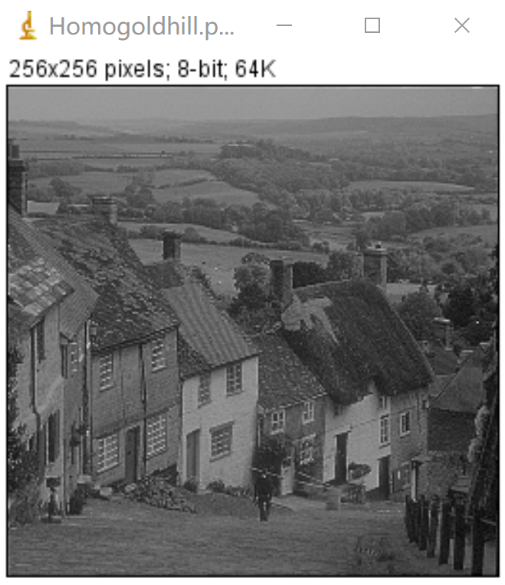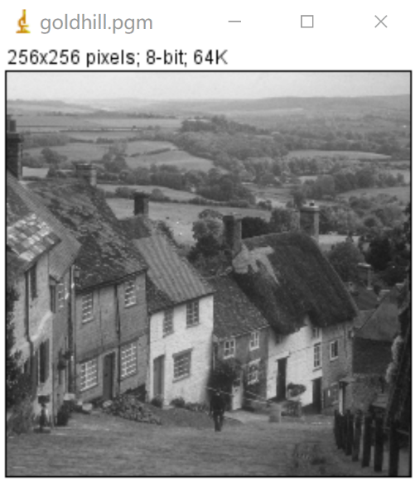

Result of processing “bridge.pgm”:

Source Image: Result after homomorphic:

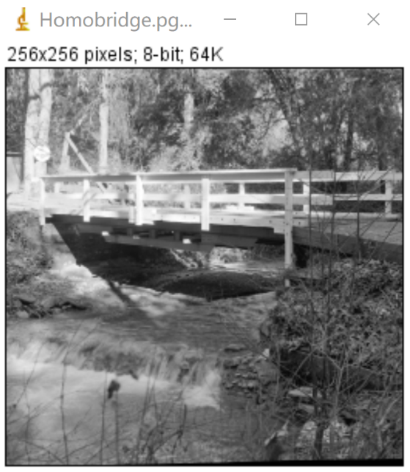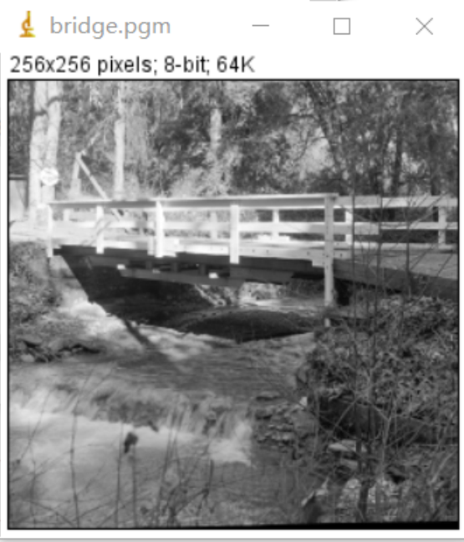

**Discussion:**

Since Laplacian is a differential operator, its application can enhance the region of sudden grayscale changes in the image and weaken the slowly changing regions of grayscale. Therefore, the sharpening process can select the Laplacian operator to process the original image to generate an image describing the gray level mutation, and then superimpose the Laplacian image with the original image to generate a sharpened image.

**Codes:**

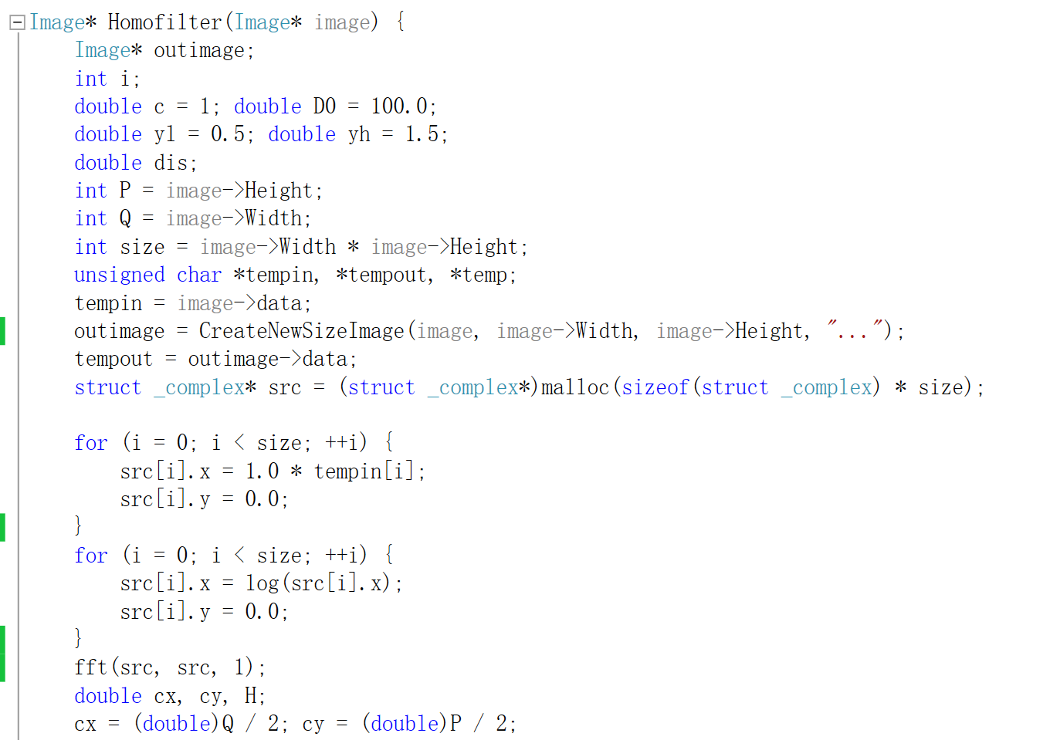 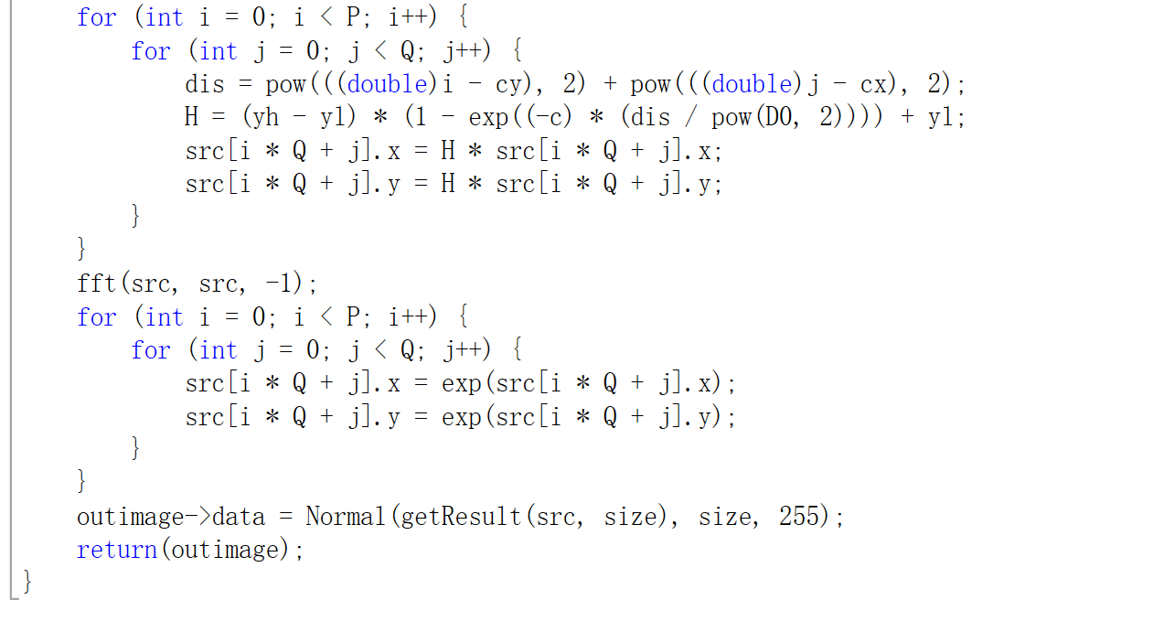

1. **Bandreject filter (lena):**

**Algorithm:**

Butterworth band stop filter.Generated according to the following guidelines:

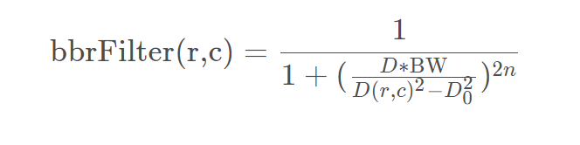

**Results (including pictures):**

Result of processing “Lena.pgm”:

Source Image: Result after band reject filter:

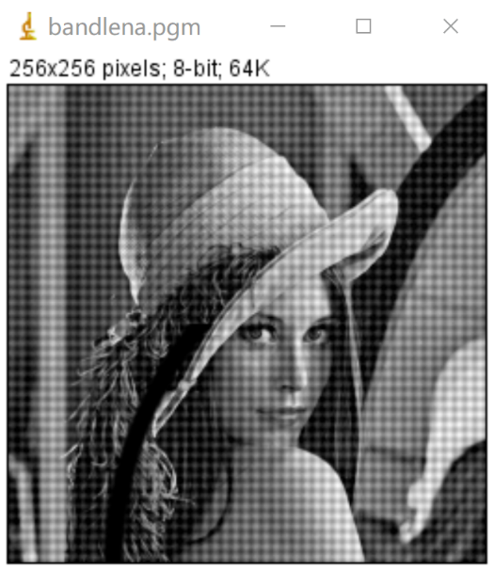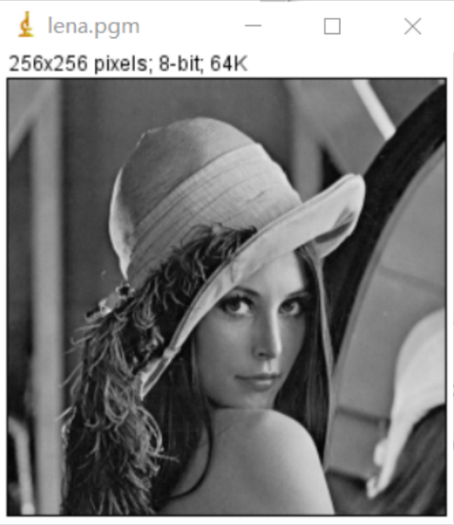

**Discussion:**

The pass or fail of the circular ring can be used to eliminate periodic noise.

**Codes:** 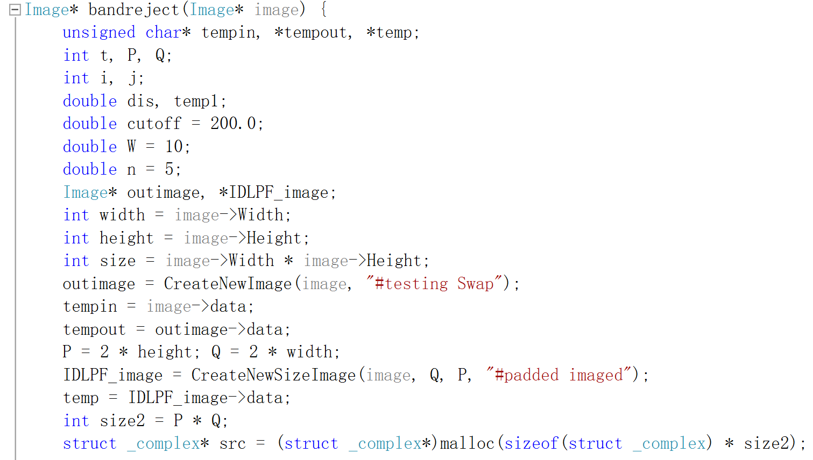 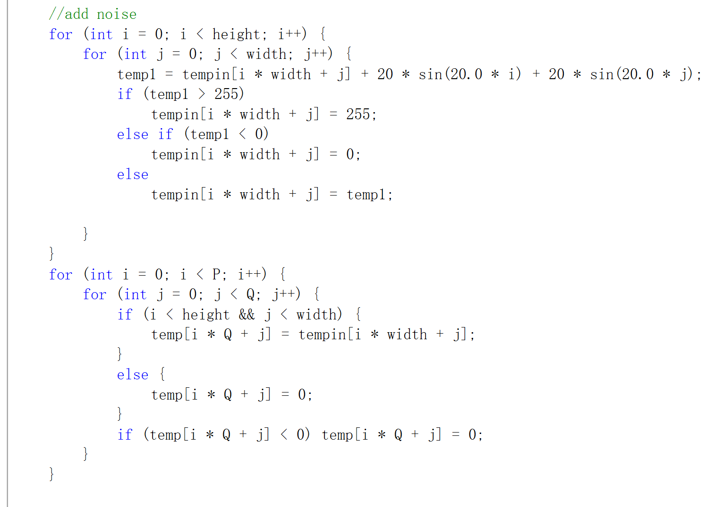 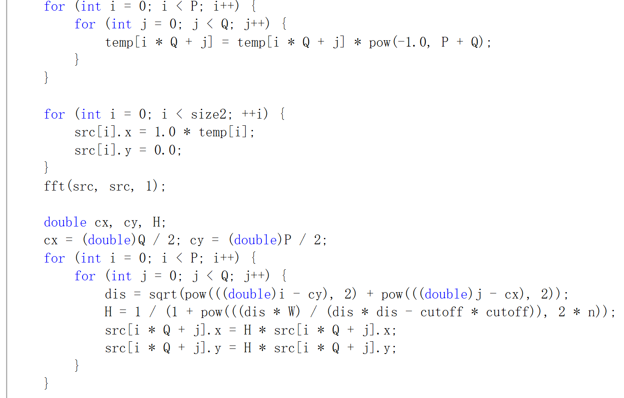 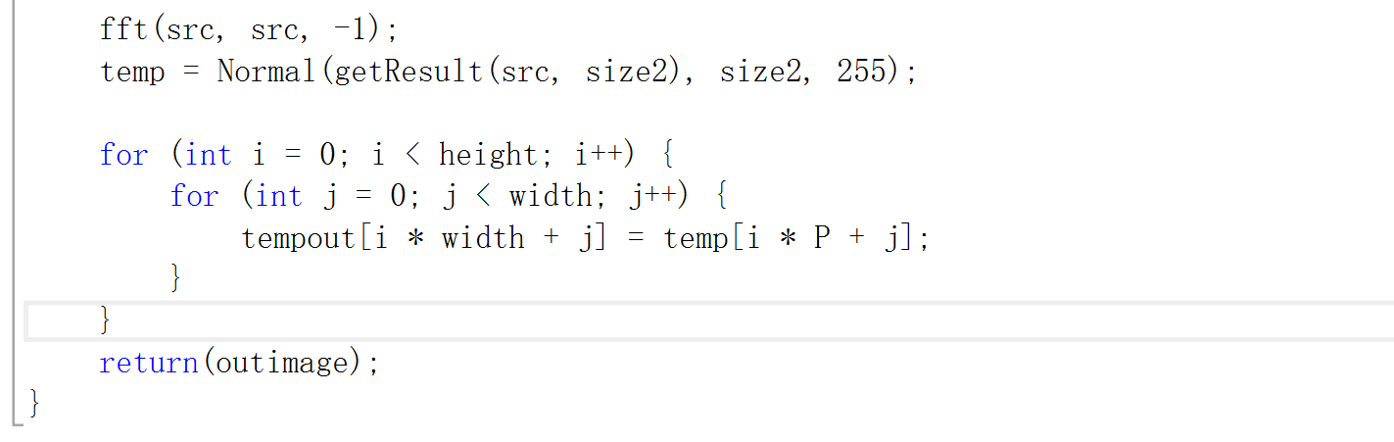

1. **Reduce noise(lenaWithNoise, bridgeWithNoise):**

**Algorism**

Lena uses band reject filter, same as 2.

Bridge uses median filter.

Input: a unsigned char array that stores the source image data

Output: a unsigned char array that stores the output image data

For inImage(i, j):

Store its’ 3 x 3 neighbor including itself in a unsigned char array **local**[9];

Find out the median of **local**;

Assign the median to outImage(i,j) => $outData[i*width+j]=findMedian(local,9)$

END

**Results (including pictures):**

Result of processing “LenaWithNoise.pgm”:

Source Image: Result after reduce noise:

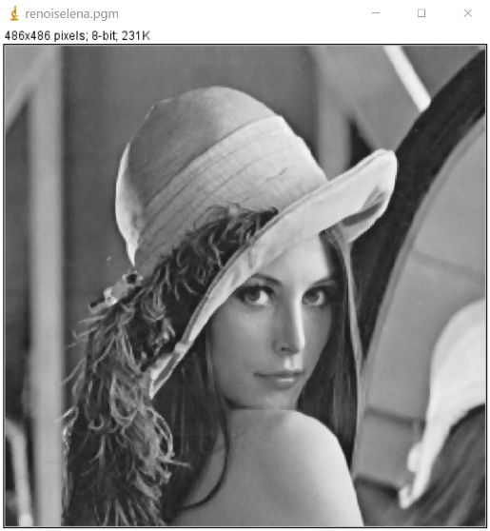 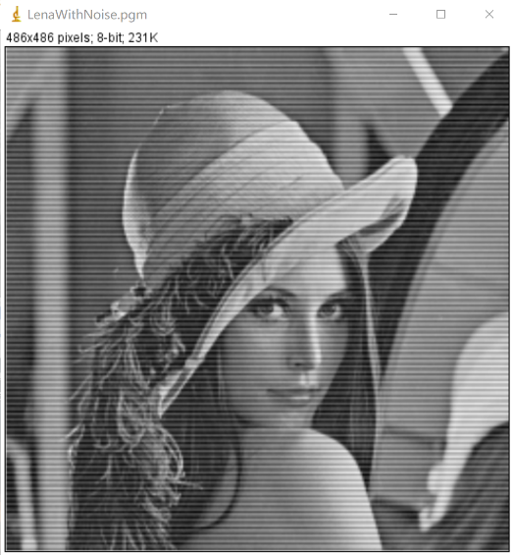

Result of processing “bridgeWithNoise.pgm”:

Source Image: Result after reduce noise:

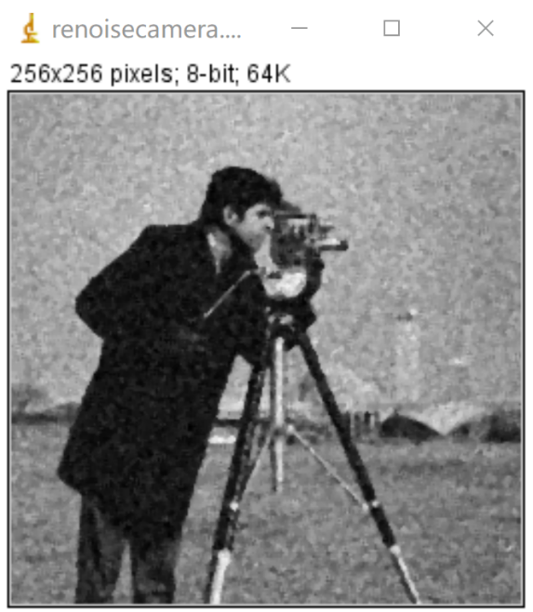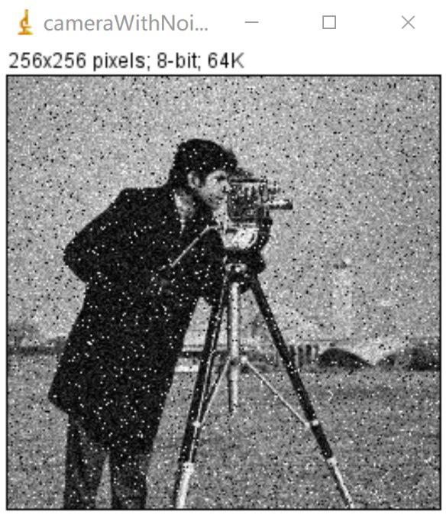

**Discussion:**

Same as 2.

The median filter also smooths the input image. But the result of median filter is sharper than that of average filter. Median filter simply substitutes the target pixel with the median of its 3 x 3 neighbor, that is, the operation does not operate all pixels in the neighbor. So the differences between pixels in the output image by median filter is larger than that by average filter.

**Codes:**

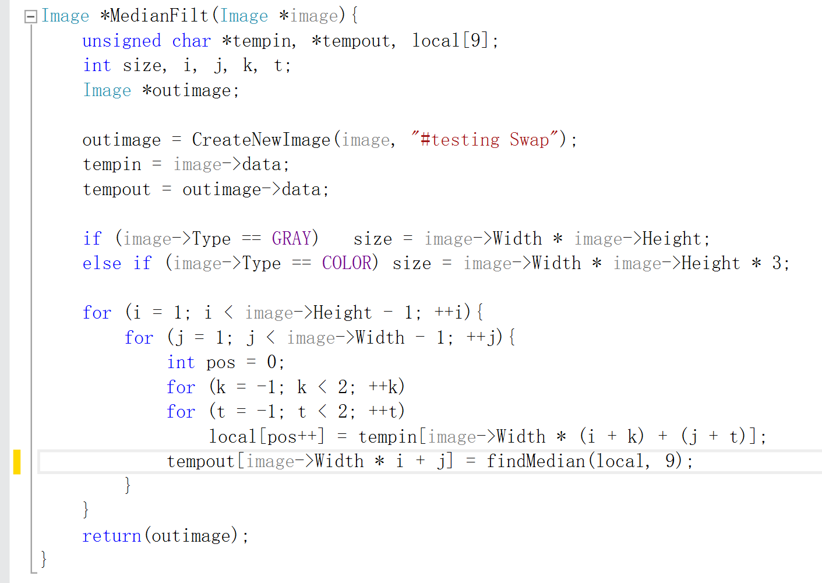 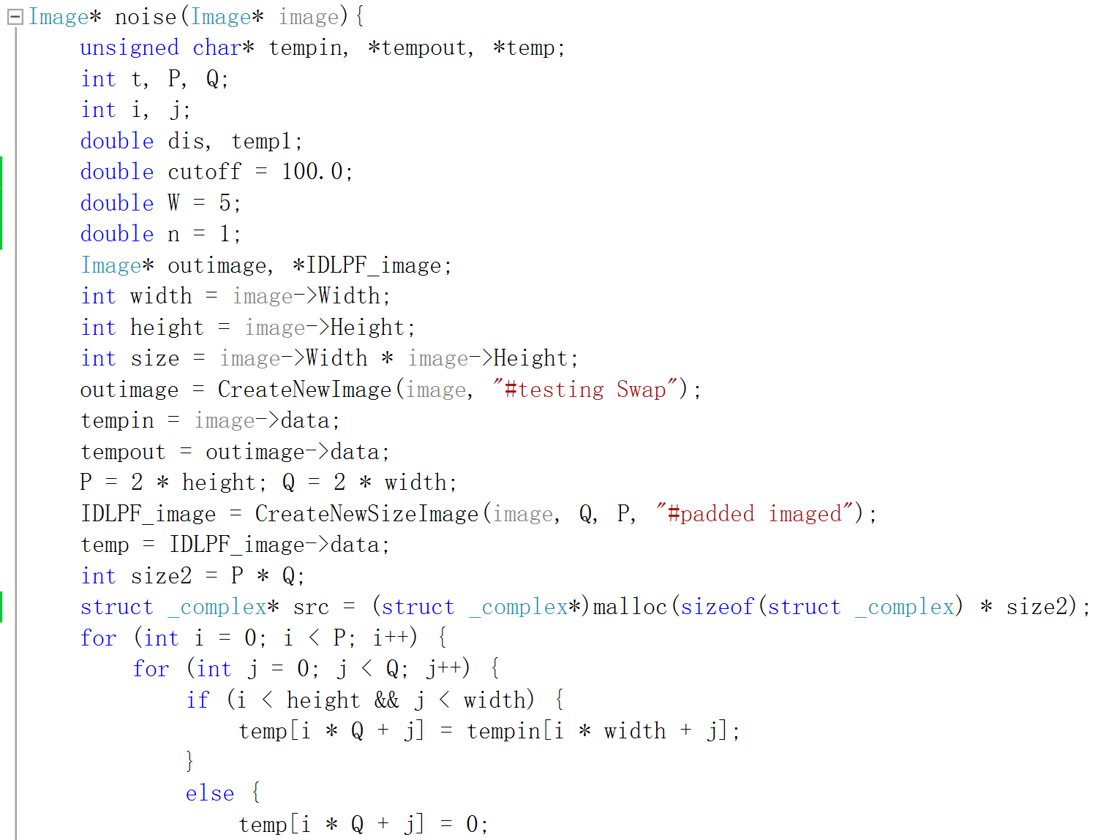 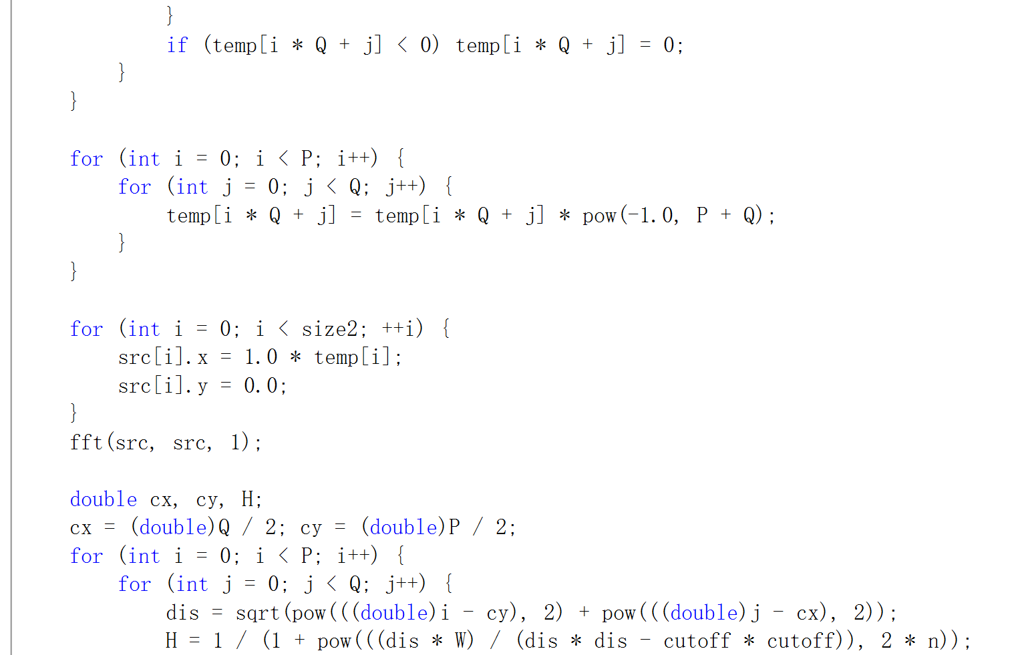 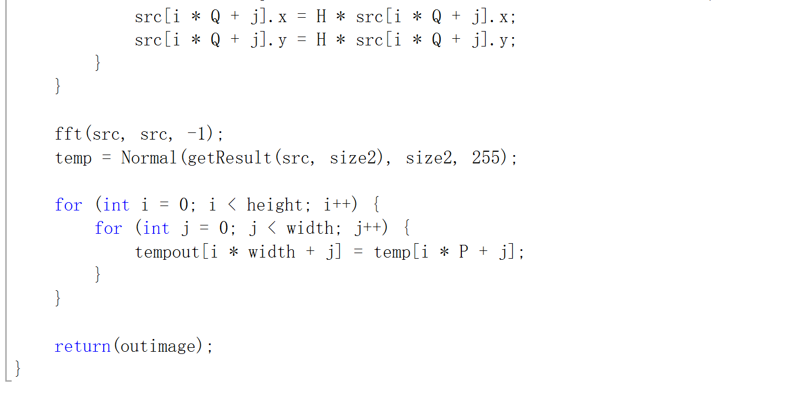

1. **Filter (lenaD1, lenaD2, lenaD3):**

* arithmetic mean filter

**Algorithm:**

Let $Sxy$ denote a filter window with a center point at $(x, y)$ and a size of $m×n$. The arithmetic mean filter simply calculates the average value of the pixels in the window area, and then assigns the average value to the pixel at the center of the window:

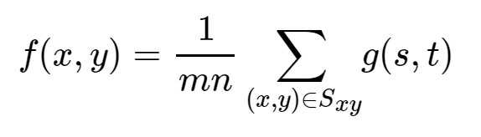

Among them, $g(s,t)$ represents the original image, and $f(x,y)$ represents the image obtained after mean filtering.

Based on the above formula, the window template of the arithmetic mean filter can be easily obtained. The following is an example of 3×3.

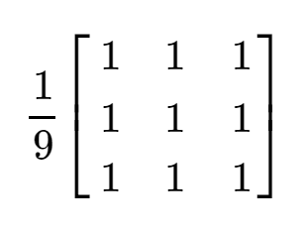

**Results (including pictures):**

Result of processing “LenaD1.pgm”:

* Source Image: Result after arithmetic mean filter:

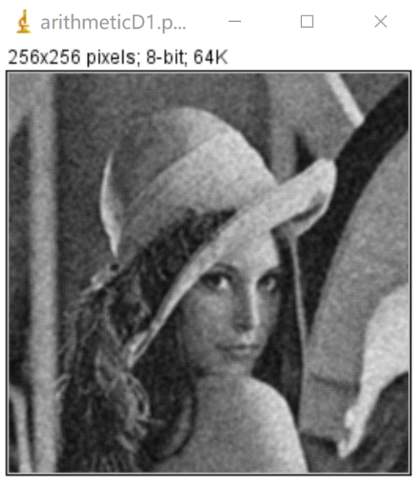 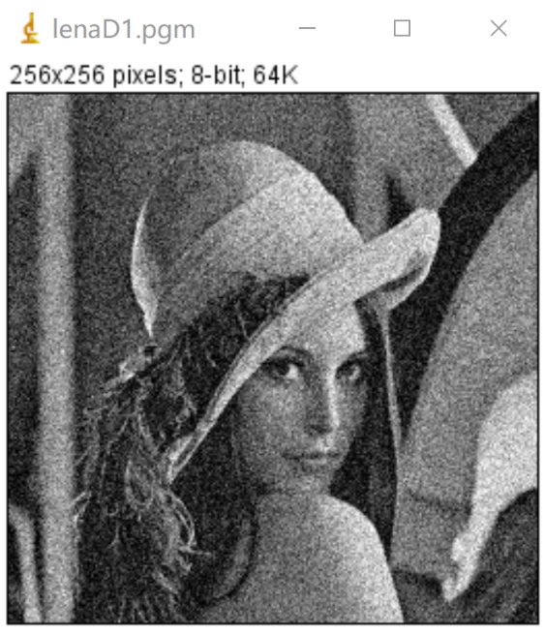

Result of processing “LenaD2.pgm”:

* Source Image: Result after arithmetic mean filter:

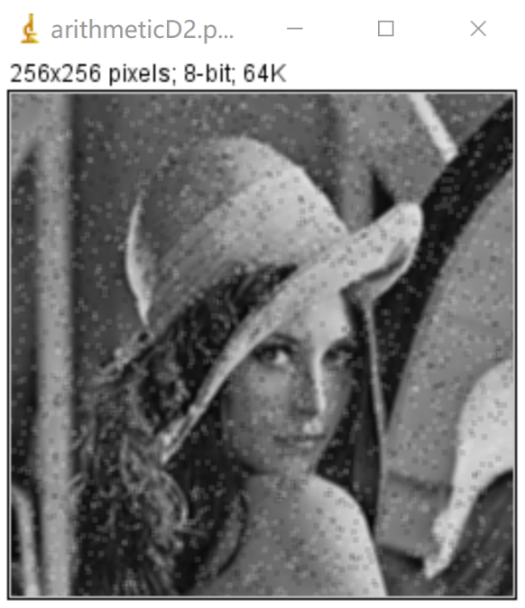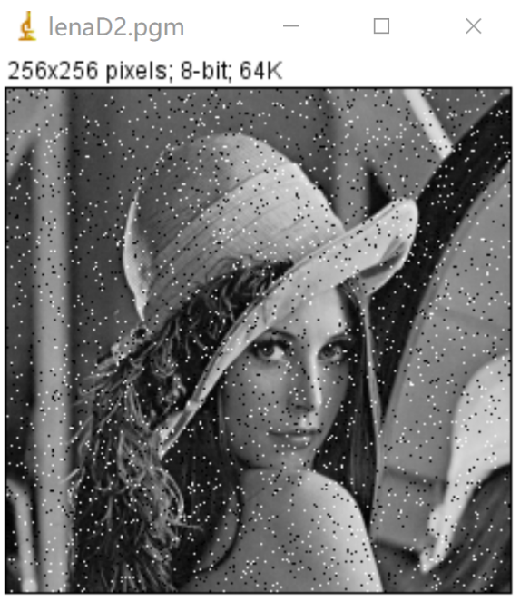

Result of processing “LenaD3.pgm”:

* Source Image: Result after arithmetic mean filter:

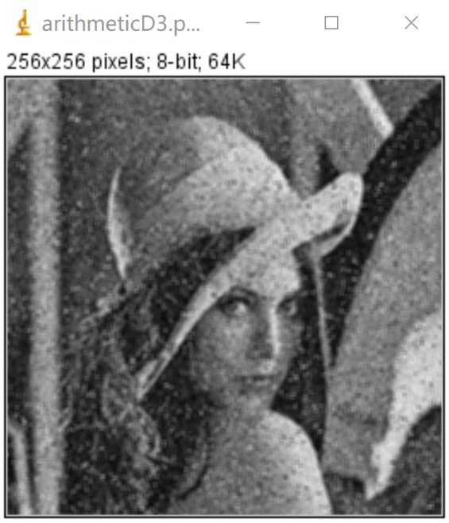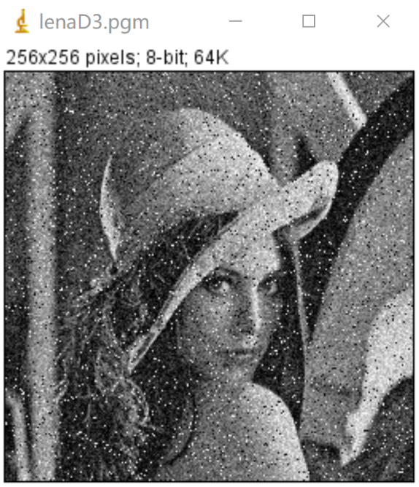

**Discussion:**

This is the simplest average filter, which can remove uniform noise and Gaussian noise, but it will cause a certain degree of blurring of the image. The first picture is processed smoothly.

**Codes:**

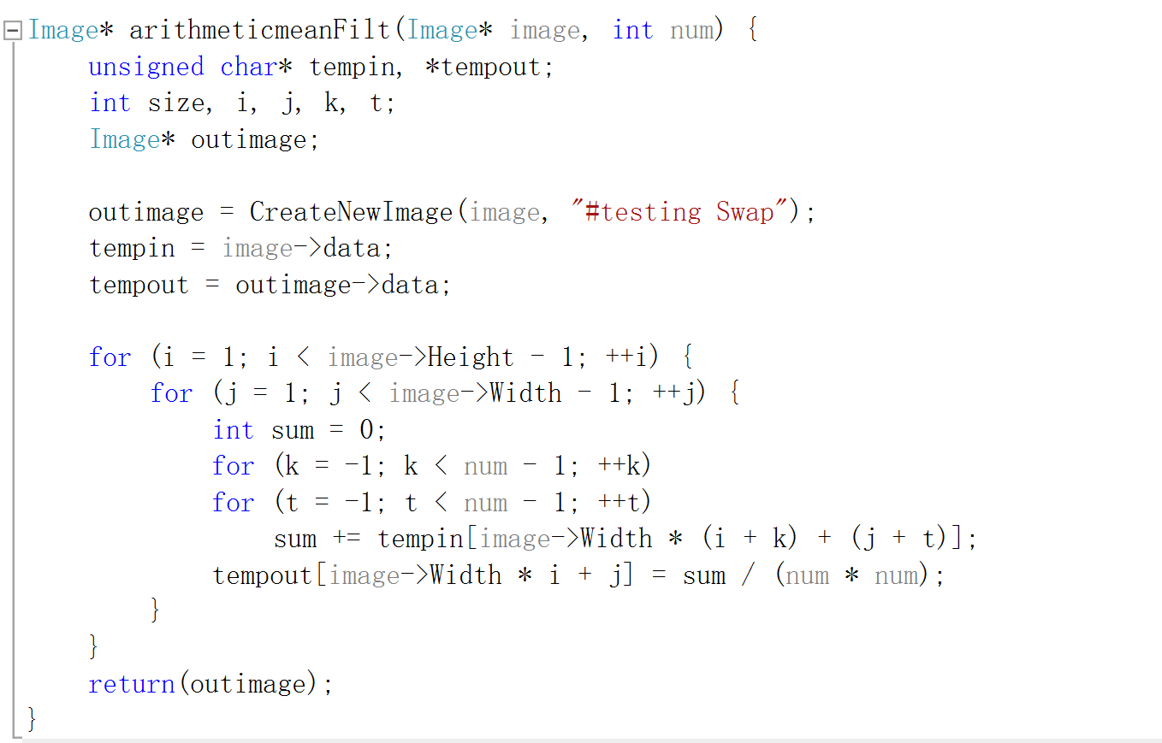

* geometric mean filter

**Algorithm:**

Multiply the elements of the sub-window (need to determine whether it is zero), and raise the product to the power of $1/m*n.$

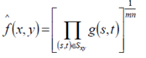

**Results (including pictures):**

Result of processing “LenaD1.pgm”:

* Source Image: Result after geometric mean filter:

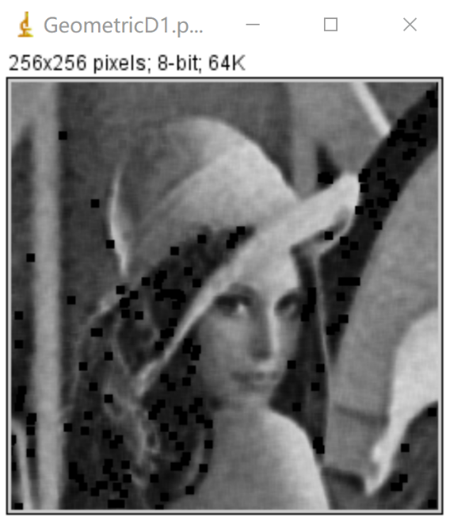 

Result of processing “LenaD2.pgm”:

* Source Image: Result after geometric mean filter:

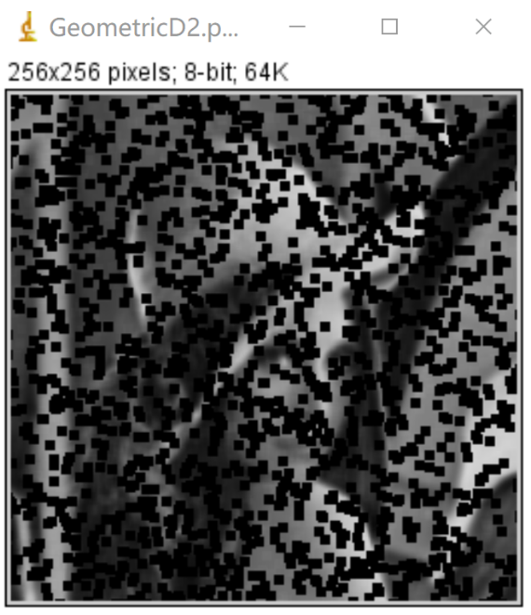

Result of processing “LenaD3.pgm”:

* Source Image: Result after geometric mean filter:

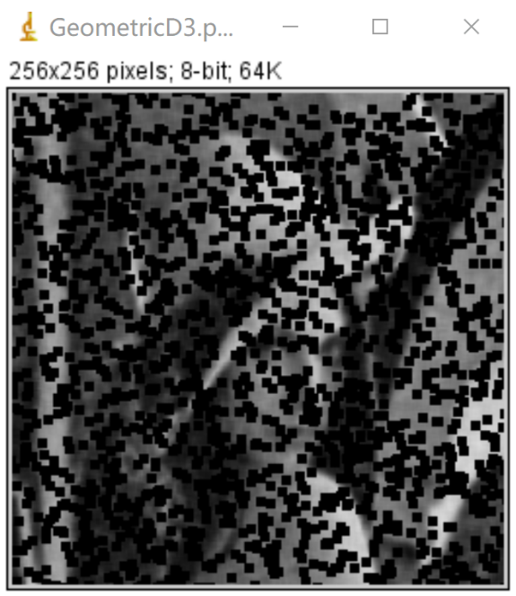

**Discussion:**

The results show that the denoising effect is not ideal. And after each picture is processed, black blocks will be produced, which cannot achieve a good smoothing effect.

**Codes:**

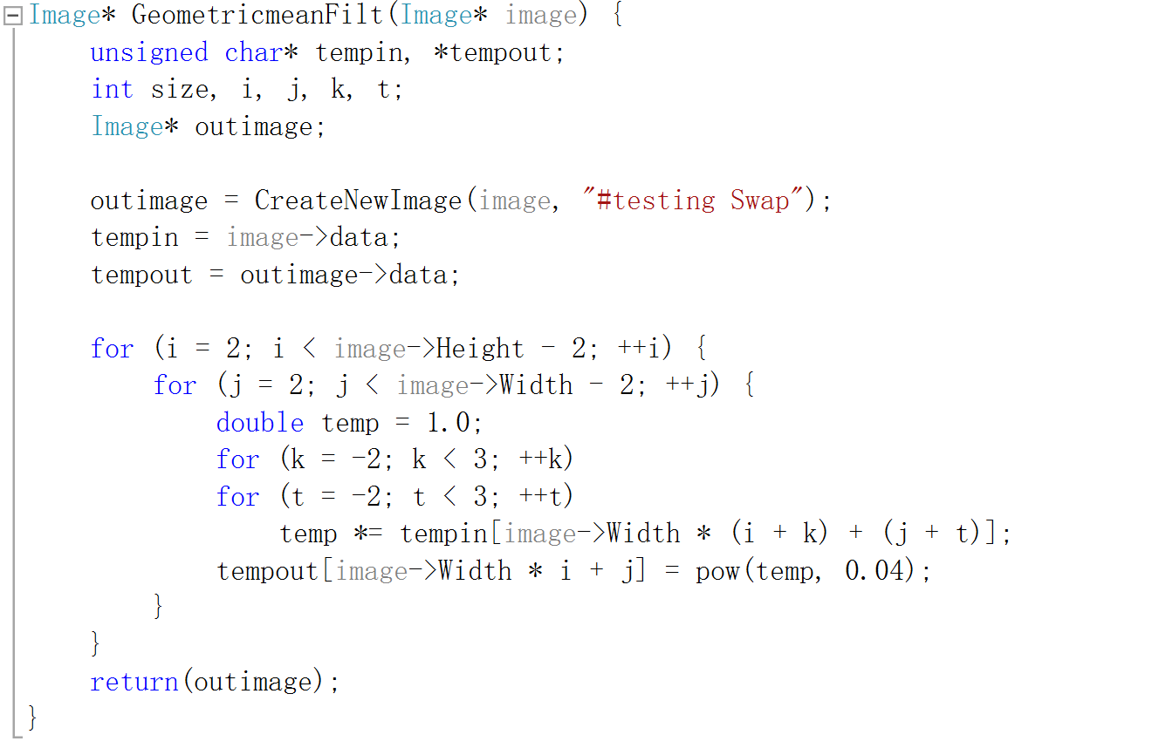

* median filter

**Algorithm:**

Input: a unsigned char array that stores the source image data

Output: a unsigned char array that stores the output image data

For inImage(i, j):

Store its’ 3 x 3 neighbor including itself in a unsigned char array **local**[9];

Find out the median of **local**;

Assign the median to outImage(i,j) => $outData[i*width+j]=findMedian(local,9)$

END

Function findMedian() use bubble sort to find the 5th smallest value of **local**.

**Results (including pictures):**

Result of processing “LenaD1.pgm”:

* Source Image: Result after median filter:

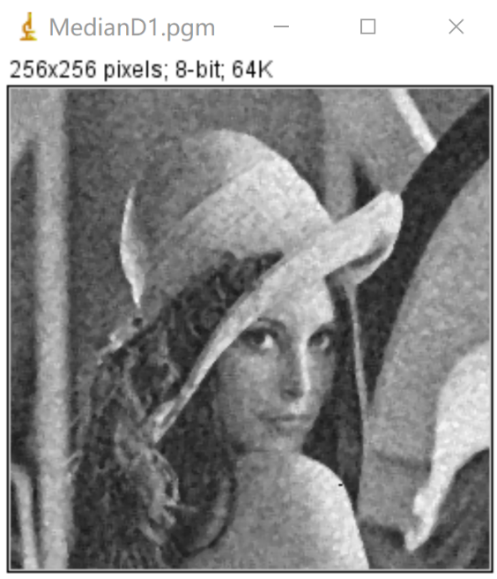 

Result of processing “LenaD2.pgm”:

* Source Image: Result after median filter:

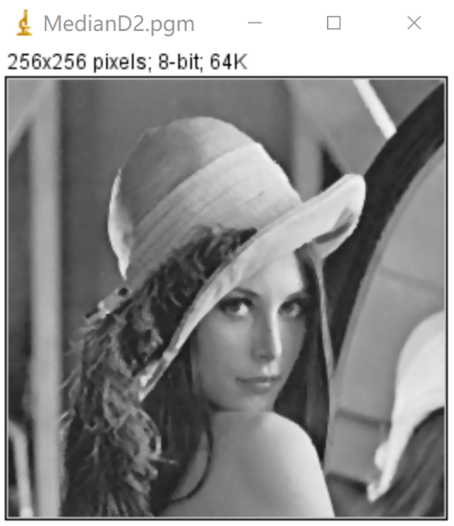

Result of processing “LenaD3.pgm”:

* Source Image: Result after median filter:

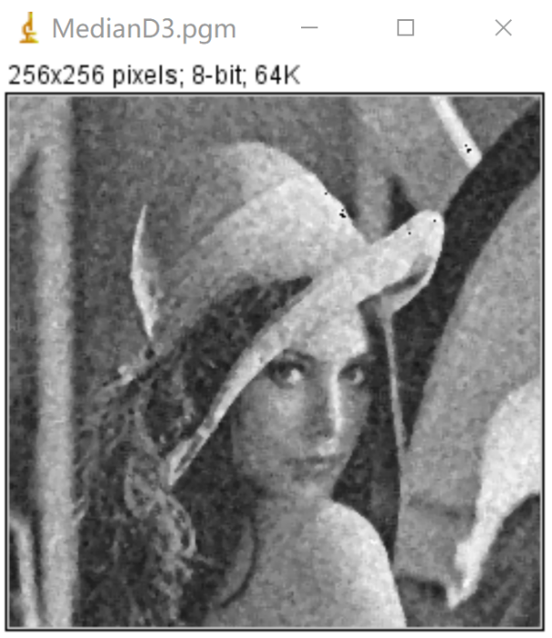



**Discussion:**

The median filter also smooths the input image. But the result of median filter is sharper than that of average filter. Median filter simply substitutes the target pixel with the median of its 3 x 3 neighbor, that is, the operation does not operate all pixels in the neighbor. So the differences between pixels in the output image by median filter is larger than that by average filter. It has a good effect on three pictures, especially for salt and pepper noise processing.

**Codes:**

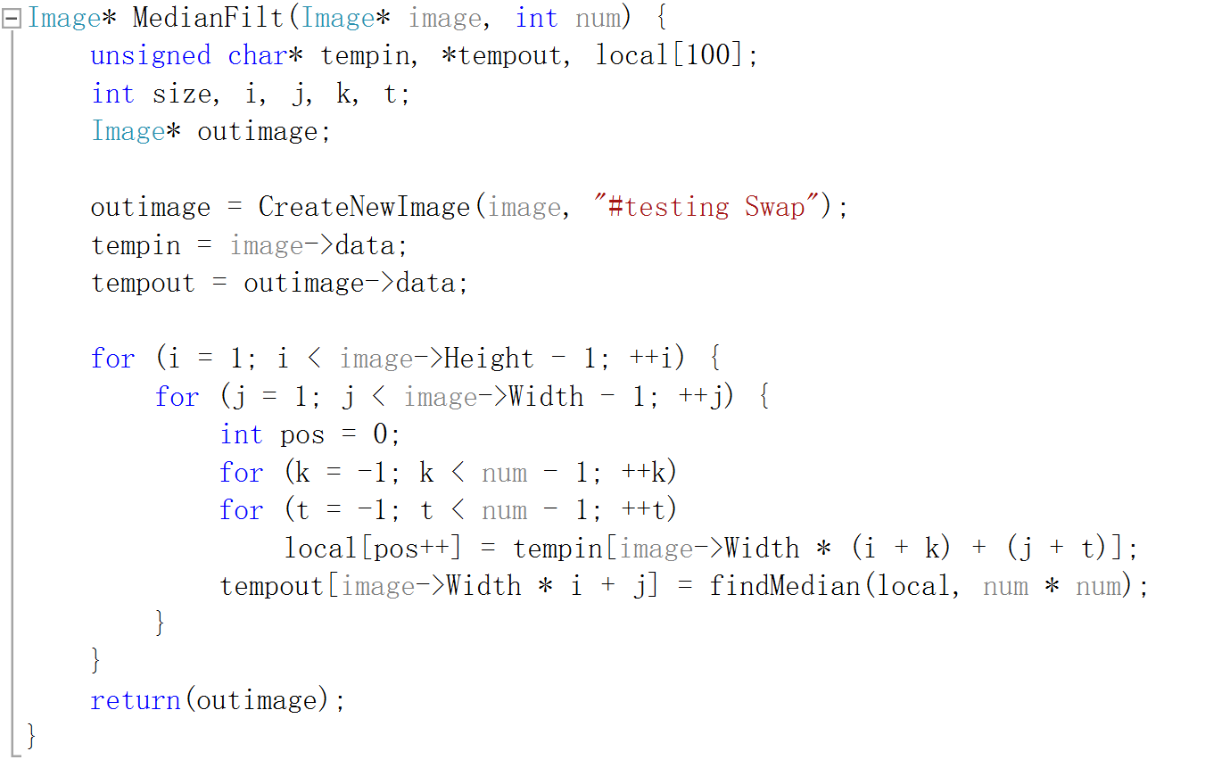

* Alpha-trimmed mean filter

**Algorithm:**

The modified alpha mean filter is similar to the method of removing the highest score and removing the lowest score to evaluate a player's level, that is, sort the data in the filtering range, remove d data from large to small, and remove d from small to large. Data, calculate the average of the remaining data.

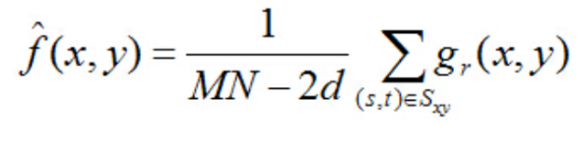

**Results (including pictures):**

Result of processing “LenaD1.pgm”:

* Source Image: Result after Alpha-trimmed mean filter:

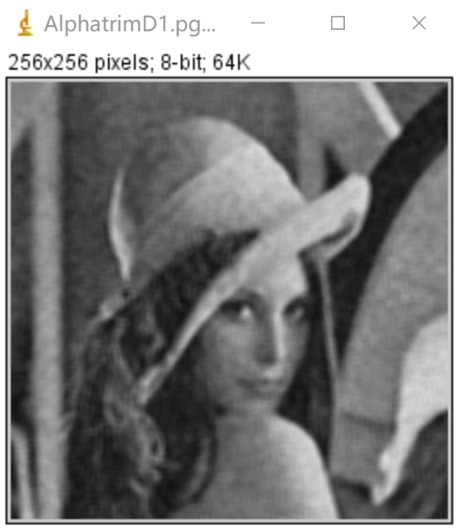 

Result of processing “LenaD2.pgm”:

* Source Image: Result after Alpha-trimmed mean filter:

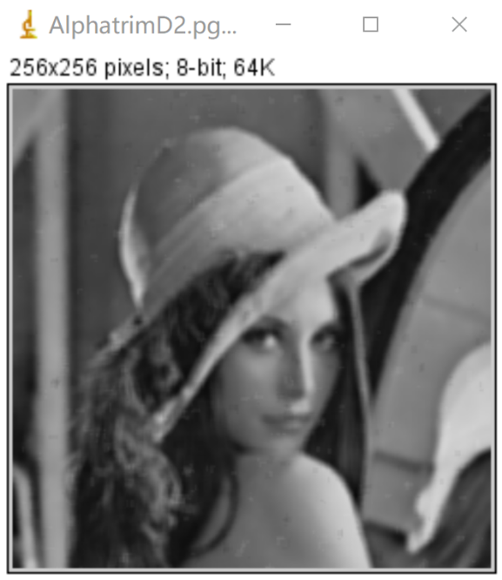

Result of processing “LenaD3.pgm”:

* Source Image: Result after Alpha-trimmed mean filter:

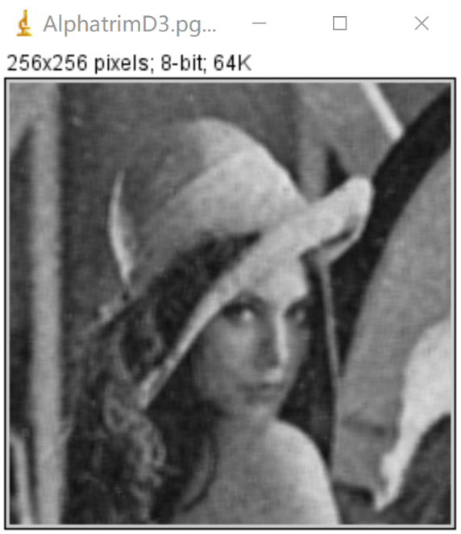

**Discussion:**

Very good at removing pictures that have been contaminated by salt and pepper noise together with other types of noise. It processes the second image more smoothly, but a bit more blurry than the median filter.

**Codes:**

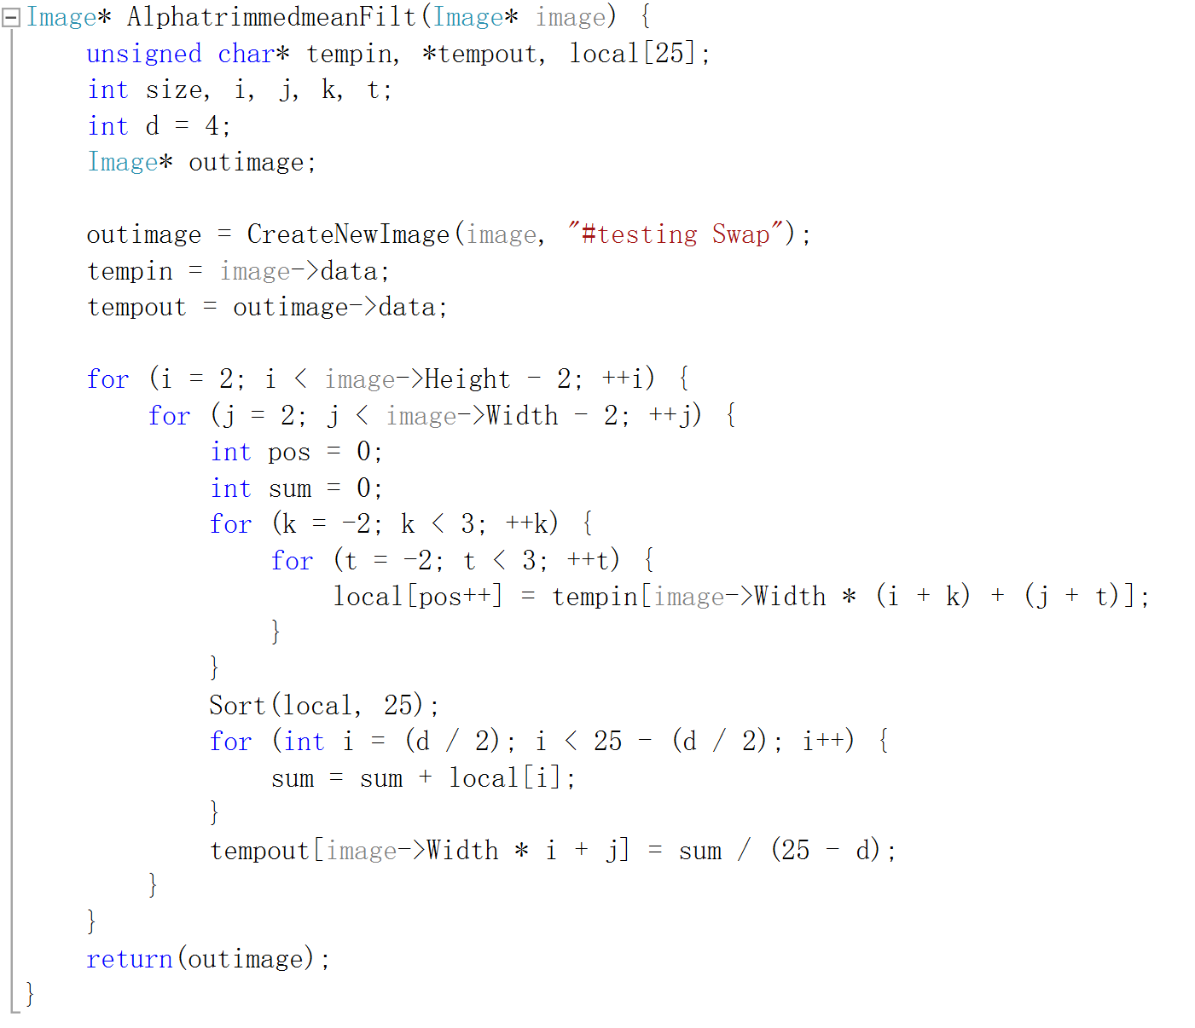

* adaptive median filter

**Algorithm:**

The following symbols are predefined:

$S_{xy}$: The active area of the filter, the area covered by the filter window. The center point of this area is the pixel in the $yth$ row and $xth$ column of the image

$Z_{min}$: The smallest gray value in $S_{xy}$

$Z_{max}$: The biggest gray value in $S_{xy}$

$Z_{med}$: The median of all gray values in $S_{xy}$

$Z_{xy}$: Indicates the gray value of the pixel in the $yth$ row and $xth$ column of the image

$S_{max}$: Maximum window size allowed by $S_{xy}$

The adaptive median filter is divided into the following two processes, A and B:

A:

1. A1 = -

2. A2 = -

3. If A1>0A1>0 and A2<0A2<0, then jump to B

4. Otherwise, increase the size of the window

5. If the enlarged size ≤, repeat A

6. Otherwise, directly output

B:

1. B1 = -

2. B2 = -

3. If B1>0B1>0 and B2<0B2<0, then output

4. Otherwise output $Z_{med}$

**Results (including pictures):**

Result of processing “LenaD1.pgm”:

* Source Image: Result after adaptive median filter:

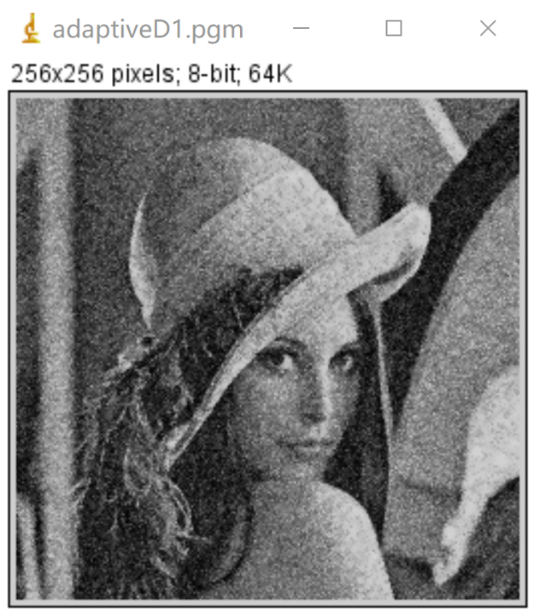 

Result of processing “LenaD2.pgm”:

* Source Image: Result after adaptive median filter:

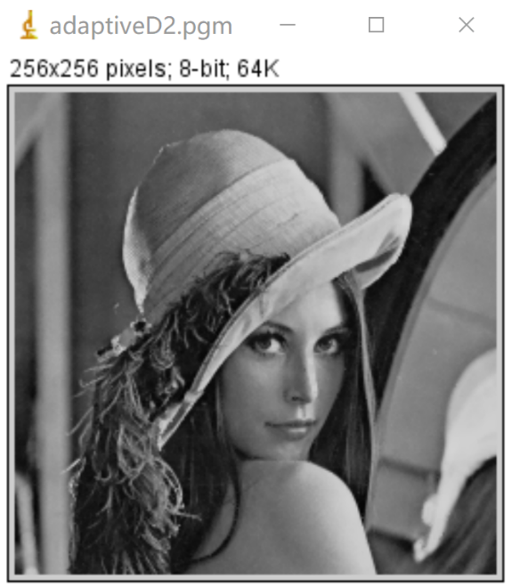

Result of processing “LenaD3.pgm”:

* Source Image: Result after adaptive median filter:

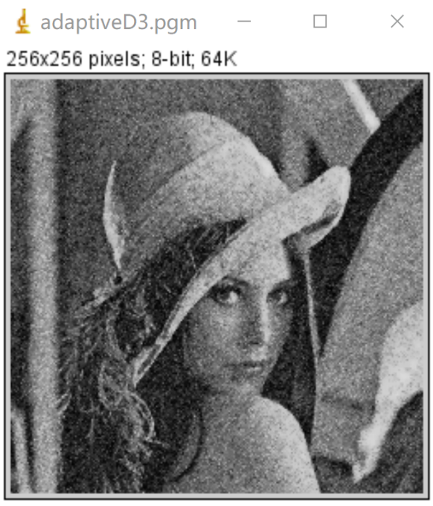

**Discussion:**

In the case where the noise density is not very large (according to experience, the probability of occurrence of noise is less than 0.2), the effect of using median filtering is good. But when the probability of noise is relatively high, the original median filtering algorithm is not very effective. Only increase the filter window size, although the image will become blurred.

The purpose of using the adaptive median filter is to dynamically change the window size of the median filter according to the preset conditions, so as to take into account the effect of noise removal and protection of details at the same time.

**Codes:**

